**Assignment 11.2 Sqoop**

**Problem Statement:**

**Mentioned all the steps:**

2. Perform incremental load in Hive

Read from MySQL Table and load it in Hive table.

Create hive table if it does not exist.

If it exists, perform the incremental load.

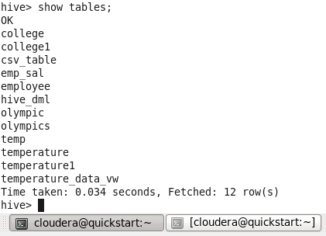

@MySQL

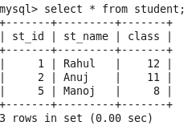

Import command :

sqoop import --connect jdbc:mysql://localhost/emp --username root --P --table student --hive-import --hive-table student -m 1

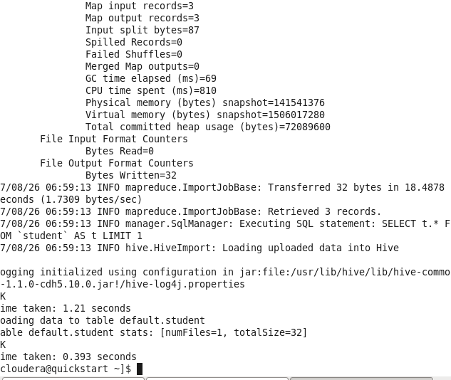

Table created @Hive

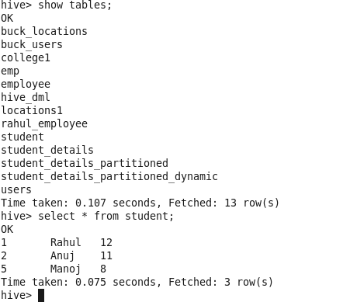

**Adding two records in student table @mysql**

**Incremental update:**

**ALTER TABLE default.student set**

**location 'hdfs://quickstart.cloudera:8020/user/cloudera/student'**

**ALTER TABLE default.student  SET SERDEPROPERTIES ('field.delim' = ',');**

**Option 1:**

**Hive over write option will work only when existing target dir will remove from hdfs.**

**hadoop fs -rm -r student**

sqoop import --connect jdbc:mysql://localhost/emp --username root --password cloudera --table student --hive-import --hive-overwrite -m 1

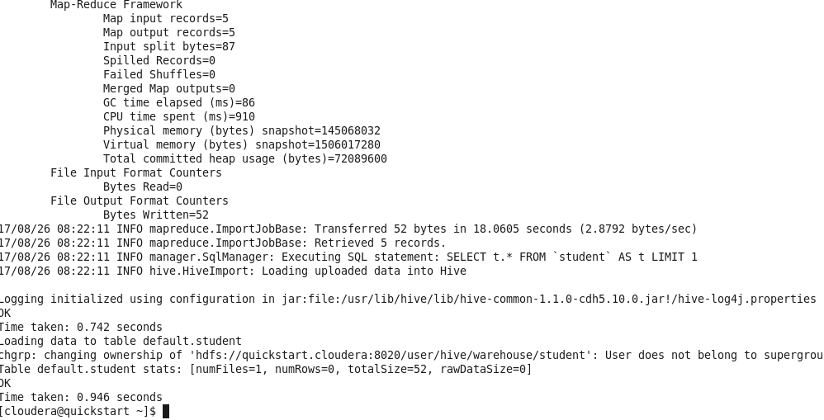

Option 2:

sqoop import --connect jdbc:mysql://localhost/emp --username root --password cloudera --table student --target-dir student --incremental append --check-column st_id --last-value 5

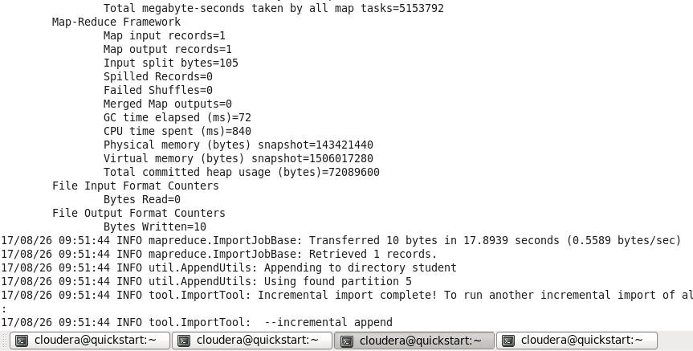

One record is updated in hive table.

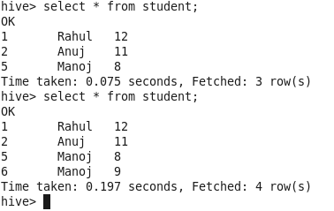

**Full load:**

sqoop import --connect jdbc:mysql://localhost/emp --username root --password cloudera --table student -- direct --target-dir student -m 1

Incremental Append Load:

sqoop import --connect jdbc:mysql://localhost/emp --username root --password cloudera --table student --target-dir student --incremental append --check-column st_id --last-value 5